Biology, Castle View High School
Jason R Mayberry, PhD
Analyzing Molecules
For each of the molecules below:
- Circle all Hydrogens involved in polar covalent bonds, and which therefore have partial positive charge, and which can therefore form Hydrogen bonds.
- Draw a Triangle all parts of the molecule to which a Hydrogen could form a Hydrogen Bond.
- Draw a Box around Hydrogens (or groups of Hydrogens) with Non-Polar Covalent bonds, and which can therefore form Van Der Walls attractions.
Note: Some of molecules below take shortcuts to simplify the drawings:
- Groups of atoms may be shown together as a chemical formula where you need to determine how they are bound together
- Not all “extra” pairs of electrons are shown
- Where two lines are connected at a corner, or a line simply ends without indicating an atom, the corner or end is assumed to be a Carbon with as many hydrogens as it needs.

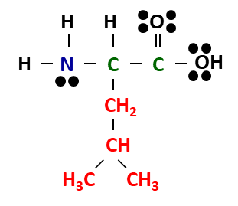 | 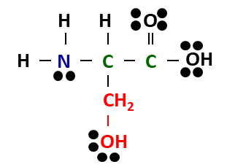 | 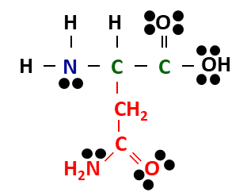
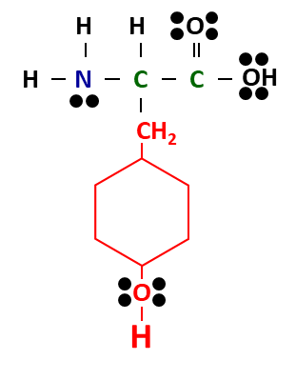 | `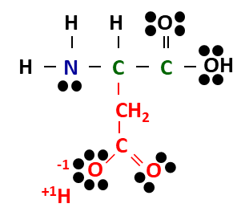 | 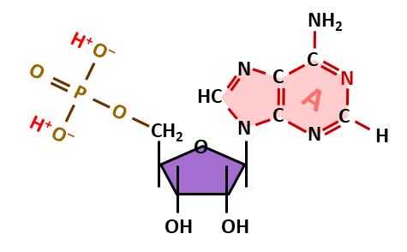
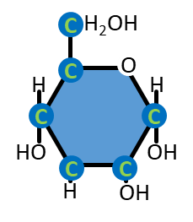 | 